**Year 12 Physics TEST # 3 – Electromagnetism 2022**

NAME:

*Total Marks: 38 Time Allowed: 45 minutes*

(Formula sheet and scientific calculator permitted)

**Question 1 (4 marks)**

The diagram shows the electric field around a positive charge. Points *X* and *Y* are equidistant from the charge, whereas *Z* is twice as far as *X* or *Y*.

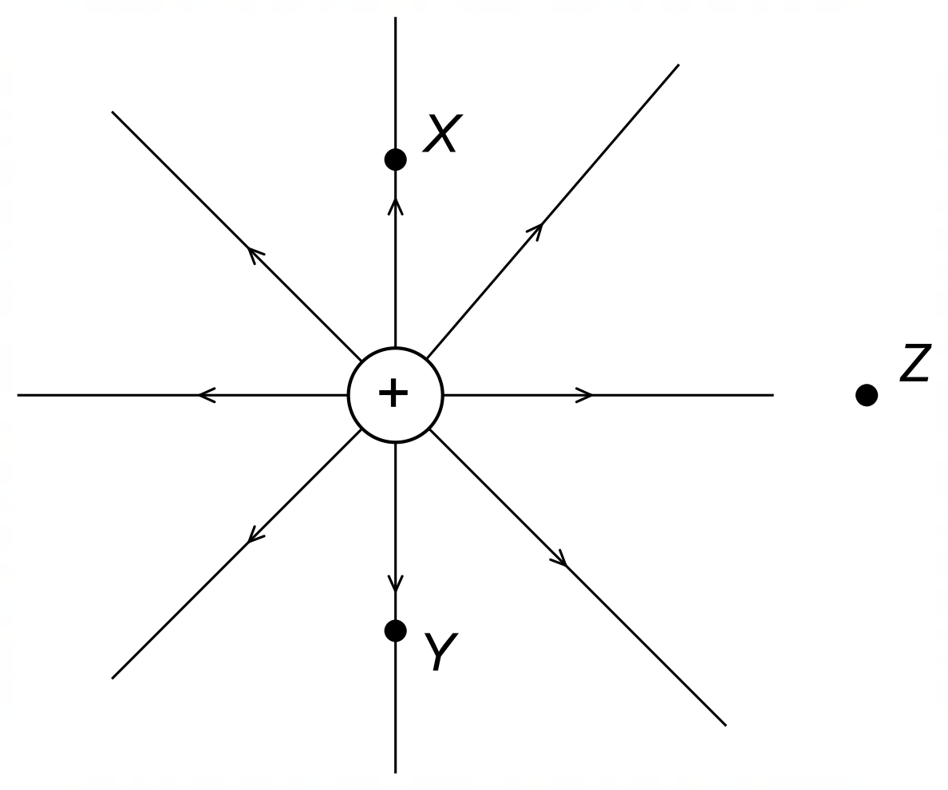

Identical charges are placed at *X* and *Y*, whereas a charge that is double the charge at *X* is placed at *Z*. These charges are very small compared with the central positive charge, so any interaction between the charges at *X*, *Y* and *Z* is negligible.

1. Compare the magnitudes of the electric fields at *X*, *Y* and *Z*. [2]
2. Compare the magnitudes of the forces on the charges at *X*, *Y* and *Z*. [2]

**Question 2 (5 marks)**

The diagram shows two parallel current-carrying wires separated by a distance of 15.0 cm.

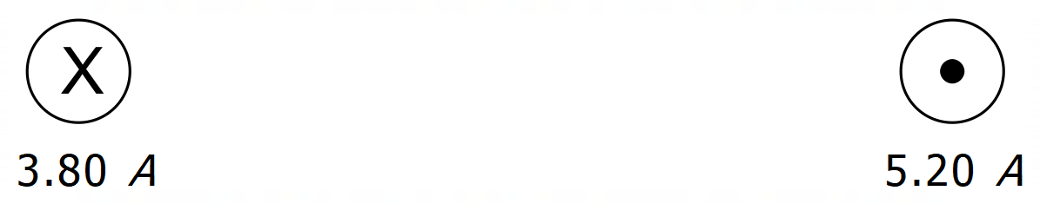

1. State the nature of the magnetic force between the wires. [1]
2. Determine the combined magnetic field strength at a point midway between the two wires. [3]
3. Describe the direction of the field in part (b). [1]

**Question 3 (8 marks)**

A DC electric motor uses a single square coil of side 4.80 cm carrying a current of 2.50A in a magnetic field of 34.0 mT.

1. What is the maximum torque on the coil? [4]
2. Soon after the motor is switched on, its frequency of rotation decreases. Explain why this happens. [4]

**Question 4 (9 marks)**

A 235 W AC generator consists of 500.0 turns of diameter 12.0 cm rotating in a magnetic field at 60.0 Hz and produces a 90.0 V rms emf.

1. What is the magnetic field strength? [3]
2. What rms current is produced? [2]
3. If the transmission wires have a resistance of 4.00 Ω, what is the percentage reduction in the power transmitted? [3]
4. Describe the transformer that would be required to step the voltage up from 90.0 V rms to 240.0 rms. [1]

**Question 5 (5 marks)**

A copper ring held parallel to the page is moved at constant speed to the right and passes through a uniform magnetic field confined to the rectangular region shown:

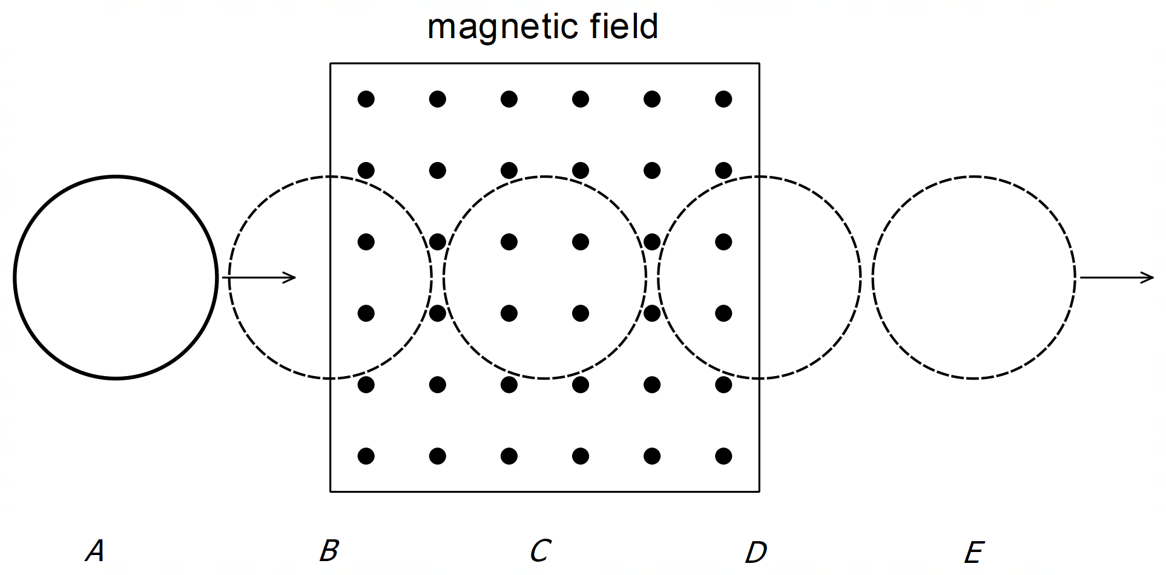

On the axes below, sketch the current induced in the ring against distance travelled, using clockwise current as positive. (No scale or units required)

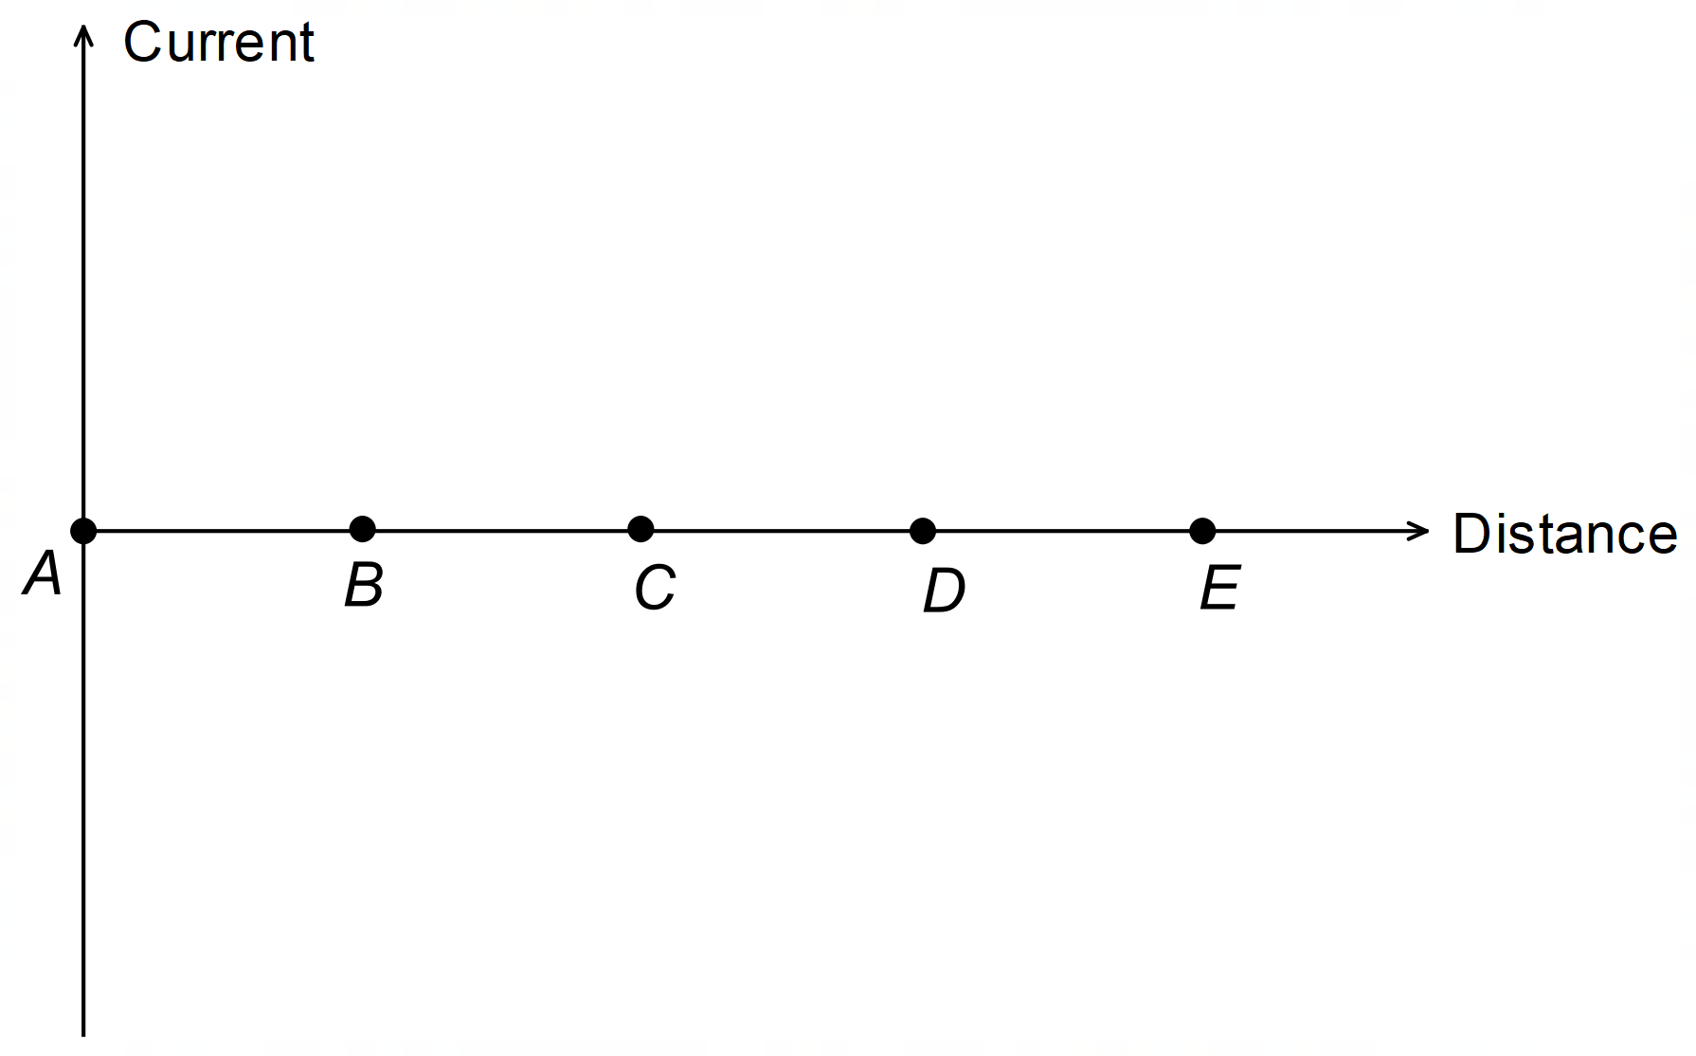

**Question 6 (7 marks)**

The diagram shows an electron about to enter a uniform electric field midway between, and parallel to, the charge plates that create the field. The potential difference between the plates is 12.0 V.

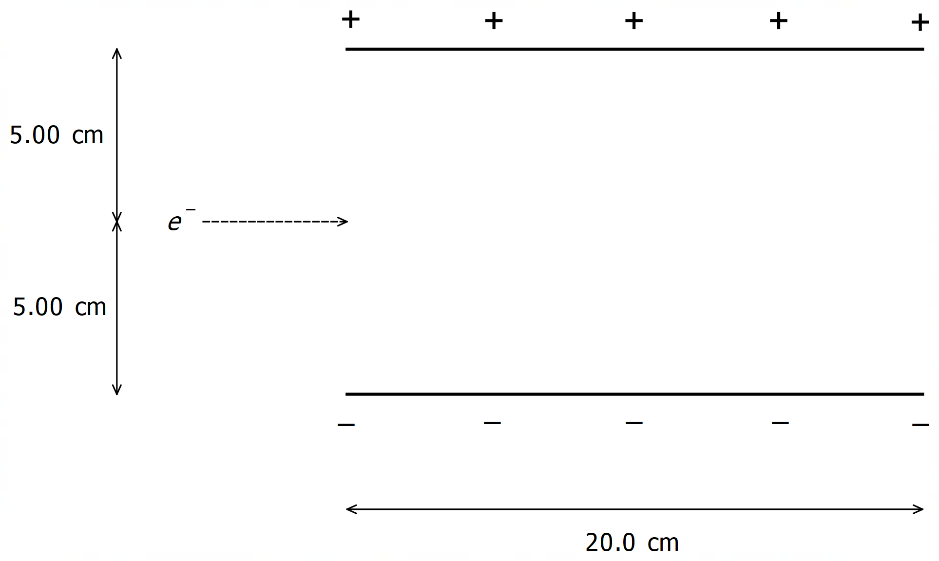

What is the minimum initial speed the electron must have to avoid crashing into one of the plates? Gravitational effects can be considered negligible. (More working space on next page)

*(Working space for Question 6)*

*- End of Questions -*